## Spectral Analysis of a random signal using Matlab

**LAB # 05**



**FALL 2021**

**CSE402L-Digital Signal Processing**

Submitted by: **Ashfaq Ahmad**

Registration No: **19PWCSE1795**

Class Section: **B**

“On my honor, as student of University of Engineering and Technology, I have neither given nor received unauthorized assistance on this academic work.”

Student Signature: ______________

Submitted to:

**Prof. Ihsan Ul Haq**

January 20, 2021

**Department of Computer Systems Engineering**

**University of Engineering and Technology, Peshawar**

**CSE 402L: Digital Signal Processing**

|  |  |  |  |  |
| --- | --- | --- | --- | --- |
| **Demonstration of Concepts** | **Poor (Does not meet expectation (1))**  The student failed to demonstrate a clear understanding of the assignment concepts | **Fair (Meet Expectation (2-3))**  The student demonstrated a clear understanding of some of the assignment concepts | **Good (Exceeds Expectation (4-5)**  The student demonstrated a clear understanding of the assignment concepts | **Score**  **30%** |
| **Accuracy** | The student completed ( <50%) tasks and provided MATLAB code and/or Simulink models with errors. Outputs shown are not correct in form of graphs (no labels) and/or tables along with incorrect analysis or remarks. | The student completed partial tasks (50% - <90%) with accurate MATLAB code and/or Simulink models. Correct outputs are shown in form of graphs (without labels) and/or tables along with correct analysis or remarks. | The student completed all required tasks (90%-100%) with accurate MATLAB code and/or Simulink models. Correct outputs are shown in form of labeled graphs and/or tables along with correct analysis or remarks. | **30%** |
| **Following Directions** | The student clearly failed to follow the verbal and written instructions to successfully complete the lab | The student failed to follow the some of the verbal and written instructions to successfully complete all requirements of the lab | The student followed the verbal and written instructions to successfully complete requirements of the lab | **20%** |
| **Time Utilization** | The student failed to complete even part of the lab in the allotted amount of time | The student failed to complete the entire lab in the allotted amount of time | The student completed the lab in its entirety in the allotted amount of time | **20%** |

**Task 01:**

First create some data. Consider data sampled at 1000 samples/sec. Start by forming a time axis for the data, running from t=0 until t=.25 in steps of 1 millisecond. Then form a signal, x, containing sine waves at 50 Hz and 120 Hz. (Hint: x = sin(2*pi*50*t) + sin(2*pi*120*t);)

**Source code:**

clc

clear all

close all

t=0:1/1000:0.25;

f1=50;

f2=120;

x=sin(2*pi*f1*t)+sin(2*pi*f2*t); %noiseless

plot(t,x,'r','Linewidth',2);

title('Noiseless Time domain Signal');

xlabel('Time axis');

ylabel('Megnitude axis');

grid on;

**Output:**

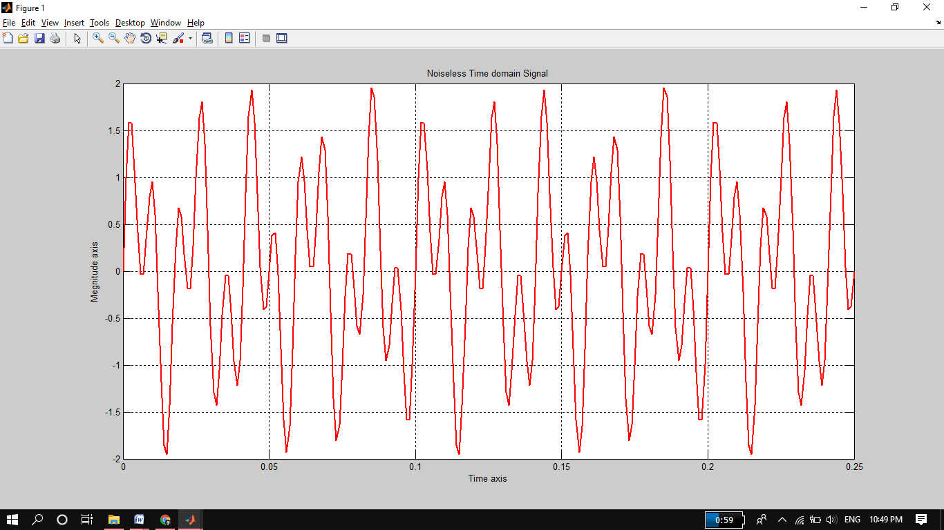

**Remarks:**

This is a composite signal of two frequencies 50 and 120 hertz. The sampling rate is 1000 per second.

**Task 02:**

Add some random noise with a standard deviation of 2 to produce a noisy signal y. Take a look at this noisy signal y by plotting it. (Hint: y = x + randn(size(t));)

**Source Code:**

clc

clear all

close all

t=0:1/1000:0.25;

f1=50;

f2=120;

x=sin(2*pi*f1*t)+sin(2*pi*f2*t);

y=x+2*rand(size(t)); %noise added by standard deviation 2.

figure

plot(t,y,'r','Linewidth',2);

title('Noisy Time domain Signal');

xlabel('Time axis');

ylabel('Megnitude axis');

grid on;

**Output:**

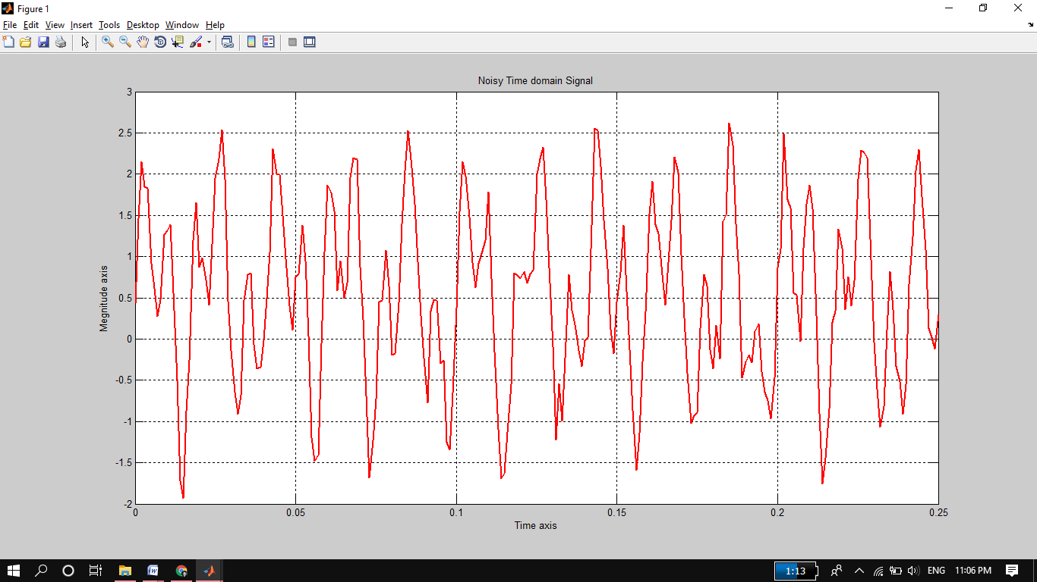

**Remarks:**

Here we have created a random signal by standard deviation of 2 using randn function then add with composite signal obtained in task 1.Then plot it. randn signal is a signal which will give different type of vector in each time of execution.

**Task 03:**

Finding the discrete Fourier transform of the noisy signal y (Hint: Y = fft(y,251);)

**Source Code:**

clc

clear all

close all

t=0:1/1000:0.25; %sampling rate 1000 per second

f1=50;

f2=120;

x=sin(2*pi*f1*t)+sin(2*pi*f2*t); %composite signal

y=x+2*rand(size(t)); %noisy signal by standard deviation 2.

n=length(y);

yfft=fft(y,n); %fast fourier transform

fshift=(-n/2:n/2-1)*(1000/n); %frequency x-axis

yshift=(fftshift(yfft));

%FFTSHIFT is useful for visualizing the Fourier transform with

%the zero-frequency component in the middle of the spectrum.

plot(fshift,abs(yshift),'r','Linewidth',2);

title('Noisy Frequency domain Signal');

xlabel('Time axis');

ylabel('Megnitude axis');

grid on;

**Output:**

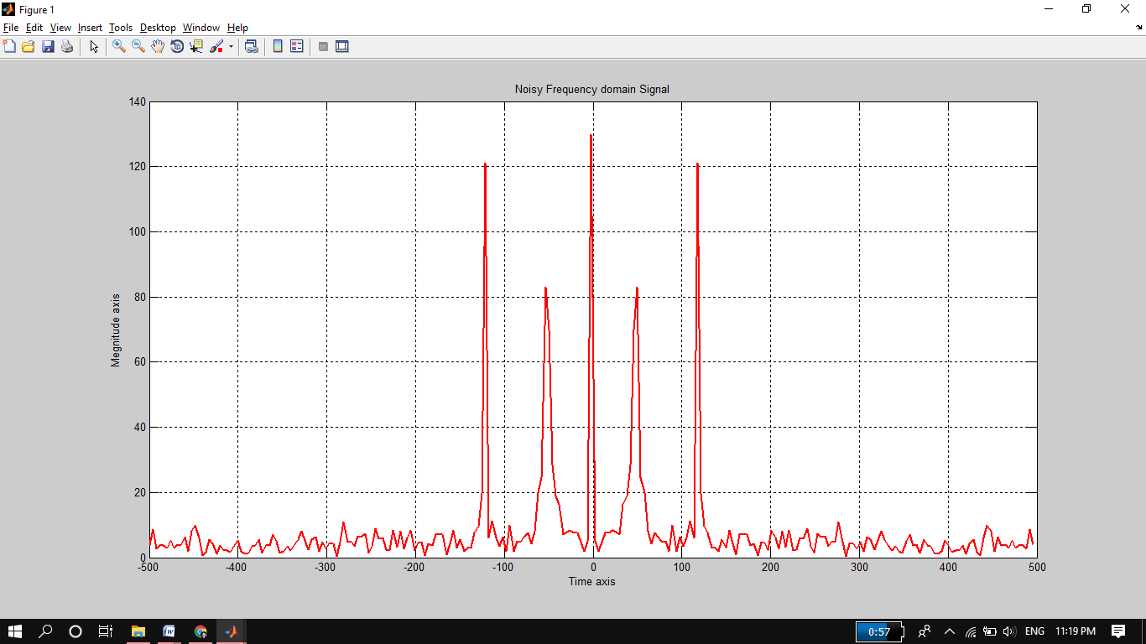

**Remarks:**

In this task we convert time domain composite signal to frequency domain. Frequency domain is better form of analyzing signal than time domain. fft command is used for converting time domain to frequency domain.

**TASK 04:**

Compute the power spectral density, a measurement of the energy at various frequencies, using the complex conjugate (CONJ). Form a frequency axis for the first 127 points and use it to plot the result.  (Hint: Pyy = Y.*conj(Y)/251; f = 1000/251*(0:127);)

**Source Code:**

clc

clear all

close all

fs = 1000;

t = 0:1/fs:.25;

x = sin(2*pi*50*t) + sin(2*pi*120*t);

y = x + 2*randn(size(t));

L = length(y);

Y = fft(y);

Pyy = Y .* conj(Y) / 251;

f = 1000/251*(0:127); %frequency axis for the first 127 points

plot(f, Pyy(1:128)); %SIZE MUST AGREED.

title('Power Spectral Density');

xlabel('Frequency');

ylabel('Power');

**Output:**

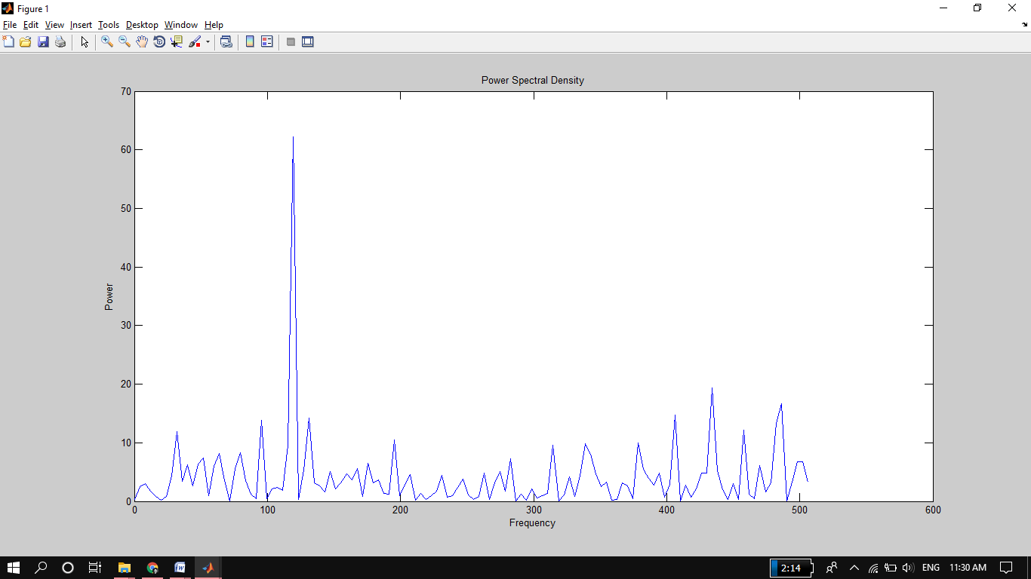

**Task 05:**

Compute and plot the periodogram using periodogram. Show that the two results are identical.

**Source Code:**

clc

clear all

close all

fs = 1000;

t = 0:1/fs:.25;

x = sin(2*pi*50*t) + sin(2*pi*120*t);

y = x + 2*randn(size(t));

f = 1000/251*(0:127);

p = periodogram(y);

plot(f, p(1:128)); %SIZE MUST AGREED.

title('Periodogram Power Spectral Density Estimate');

xlabel('Frequency');

ylabel('Power');

**Output:**

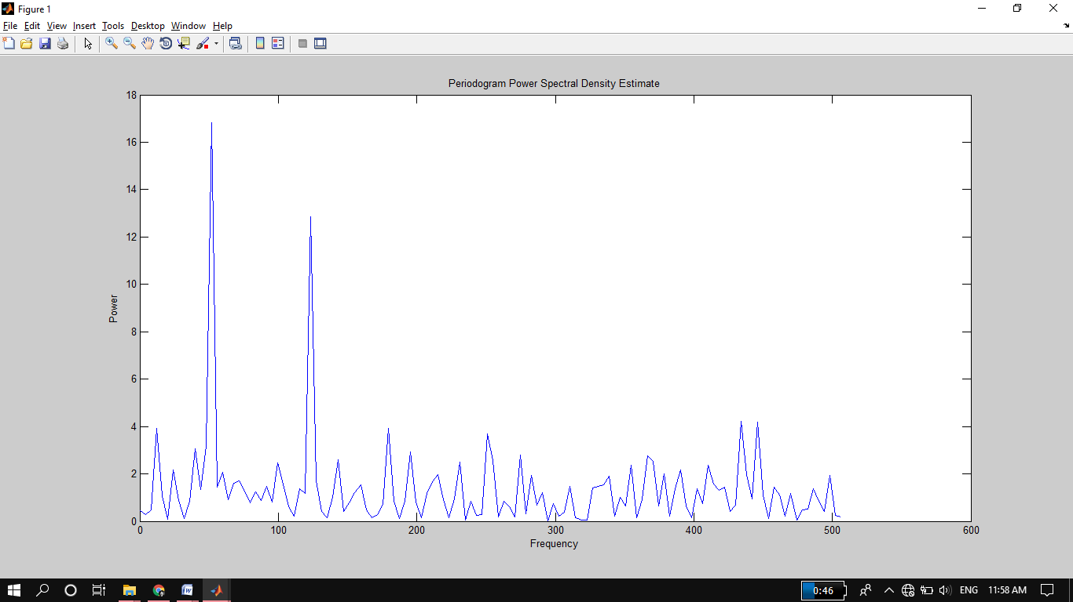

**Task 06:**

Zoom in and plot only up to 200 Hz. Notice the peaks at 50 Hz and 120 Hz. These are the frequencies of the original signal. ( Hint: plot(f(1:50),Pyy(1:50))

**Source Code:**

clc

clear all

close all

fs = 1000;

t = 0:1/fs:.25;

x = sin(2*pi*50*t) + sin(2*pi*120*t);

y = x + 2*randn(size(t));

L = length(y);

Y = fft(y);

Pyy = Y .* conj(Y) / 251;

f = 1000/251*(0:127);

plot(f(1:50), Pyy(1:50)); %for zoom in

%plot(f, Pyy(1:128));

title('Power Spectral Density');

xlabel('Frequency');

ylabel('Power');

**Output:**

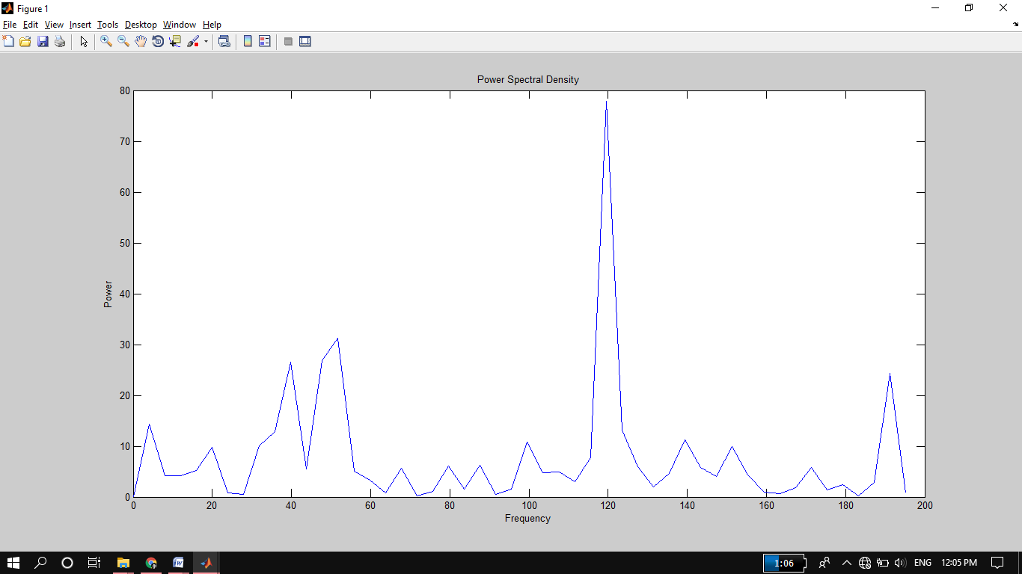

**Task 07:**

**Final Remarks:**

Final Remark of this lab is, first we have plotted noiseless signal of two frequencies 50Hz and 120Hz then we have added some noise to noiseless signal using randn function. Then we compared both plots we saw some distortion in noise added signal. But these plots are in time domain while in time domain we can’t analyze the spectrum of the signal properly. So for better understanding we have plotted the noise added signal in frequency domain using fast Fourier transform. In frequency domain we can see all frequencies components in present in signal spectrum. Then we power spectral density (a measurement of the energy at various frequencies) using the complex conjugate (CONJ). After that we have find periodgoram of noise added signal. After that we have zoom in the graph of power spectral density and then plot it. Finally we concluded that we can play with the spectrum of a signal by different aspects.